**PRENUME:___________________**



**FIȘĂ DE LUCRU**

**1. CALCULEAZĂ.**

**1**

**-**

**=**

**1**

**4**

**2**

**-**

**=**

**1**

**5**

**4**

**-**

**=**

**1**

**7**

**6**

**-**

**=**

**1**

**8**

**7**

**-**

**=**

**1**

**9**

**2**

**-**

**=**

**1**

**6**

**5**

**-**

**=**

**1**

**8**

**3**

**-**

**=**

**1**

**6**

**6**

**-**

**=**

**1**

**7**

**88**

**-**

**=**

**1**

**9**

**2. CALCULEAZĂ.**

**-**

**3**

**6**

**7**

**1**

**-**

**6**

**5**

**9**

**2**

**-**

**8**

**44**

**7**

**7**

**-**

**9**

**1**

**8**

**4**

**-**

**6**

**3**

**6**

**3**

**-**

**77**

**5**

**9**

**2**

**+**

**8**

**1**

**7**

**1**

**-**

**4**

**0**

**7**

**2**

**-**

**8**

**9**

**7**

**2**

**-**

**4**

**5**

**7**

**2**

**-**

**97**

**1**

**5**

**+**

**4**

**65**

**8**

**2**

**-**

**9**

**0**

**7**

**2**

**-**

**8**

**0**

**6**

**-**

**9**

**3**

**7**

**3. AFLĂ DIFERENȚA DINTRE NUMĂRUL 82 ȘI NUMERELE: 34, 45, 67 ȘI 28.**

|  |  |  |  |  |  |  |  |  |  |  |  |  |  |  |  |  |  |  |  |  |  |  |  |  |  |
| --- | --- | --- | --- | --- | --- | --- | --- | --- | --- | --- | --- | --- | --- | --- | --- | --- | --- | --- | --- | --- | --- | --- | --- | --- | --- |
|  |  |  |  |  |  |  |  |  |  |  |  |  |  |  |  |  |  |  |  |  |  |  |  |  |  |
|  |  |  |  |  |  |  |  |  |  |  |  |  |  |  |  |  |  |  |  |  |  |  |  |  |  |
|  |  |  |  |  |  |  |  |  |  |  |  |  |  |  |  |  |  |  |  |  |  |  |  |  |  |
|  |  |  |  |  |  |  |  |  |  |  |  |  |  |  |  |  |  |  |  |  |  |  |  |  |  |

**4. DIN DIFERENȚA NUMERELOR 87 ȘI 58, SCADE CEL MAI MIC NUMĂR IMPAR DE PE OAMENII DE ZĂPADĂ.**

|  |  |  |  |  |  |  |  |  |  |
| --- | --- | --- | --- | --- | --- | --- | --- | --- | --- |
|  |  |  |  |  |  |  |  |  |  |
|  |  |  |  |  |  |  |  |  |  |
|  |  |  |  |  |  |  |  |  |  |
|  |  |  |  |  |  |  |  |  |  |



**41**



**19**



**29**



**16**

**6. MICȘOREAZĂ SUCCESORUL NUMĂRULUI 82 CU 37.**

**5. IA DIN NUMĂRUL 72 PE PREDECESORUL NUMĂRULUI 27.**

|  |  |  |  |  |  |  |  |  |  |
| --- | --- | --- | --- | --- | --- | --- | --- | --- | --- |
|  |  |  |  |  |  |  |  |  |  |
|  |  |  |  |  |  |  |  |  |  |
|  |  |  |  |  |  |  |  |  |  |
|  |  |  |  |  |  |  |  |  |  |

|  |  |  |  |  |  |  |  |  |  |
| --- | --- | --- | --- | --- | --- | --- | --- | --- | --- |
|  |  |  |  |  |  |  |  |  |  |
|  |  |  |  |  |  |  |  |  |  |
|  |  |  |  |  |  |  |  |  |  |
|  |  |  |  |  |  |  |  |  |  |

**7. PE PENARELE DE PE RAFTUL UNUI MAGAZIN ESTE SCRIS PREȚUL FIECĂRUIA. CE PENAR POATE CUMPĂRA PAUL, DACĂ ARE 50 DE LEI ȘI ÎNCĂ 2 BANCNOTE DE 1 LEU. CE REST PRIMEȘTE?**

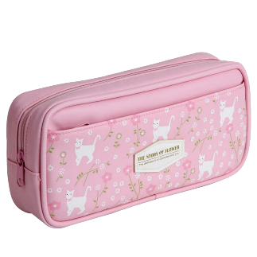

**66 LEI**

|  |  |  |  |  |  |  |  |  |  |  |  |  |  |  |  |  |  |  |  |  |  |  |  |  |  |
| --- | --- | --- | --- | --- | --- | --- | --- | --- | --- | --- | --- | --- | --- | --- | --- | --- | --- | --- | --- | --- | --- | --- | --- | --- | --- |
|  |  |  |  |  |  |  |  |  |  |  |  |  |  |  |  |  |  |  |  |  |  |  |  |  |  |
|  |  |  |  |  |  |  |  |  |  |  |  |  |  |  |  |  |  |  |  |  |  |  |  |  |  |
|  |  |  |  |  |  |  |  |  |  |  |  |  |  |  |  |  |  |  |  |  |  |  |  |  |  |
|  |  |  |  |  |  |  |  |  |  |  |  |  |  |  |  |  |  |  |  |  |  |  |  |  |  |

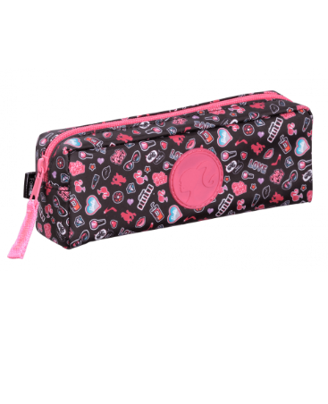

**39 LEI**

**53 LEI**

**71 LEI**